**Project Design Phase-II**

**Technology Stack (Architecture & Stack)**

|  |  |
| --- | --- |
| Date | 25 June 2025 |
| Team ID | LTVIP2025TMID44004 |
| Project Name | TrafficTelligence Advanced Traffic Volume Estimation With Machine Learning |
| Maximum Marks | 4 Marks |

**Technical Architecture:**

The Deliverable shall include the architectural diagram as below and the information as per the table1 & table 2

**Example: Order processing during pandemics for offline mode**

**Reference:** [**https://developer.ibm.com/patterns/ai-powered-backend-system-for-order-processing-during-pandemics/**](https://developer.ibm.com/patterns/ai-powered-backend-system-for-order-processing-during-pandemics/)

Guidelines:

## Technical Architecture:

This system estimates traffic volume in real time using video feeds and machine learning models. Data flows from user input or camera devices into an ML model hosted on a cloud-based server, and the results are visualized via a user-friendly dashboard.

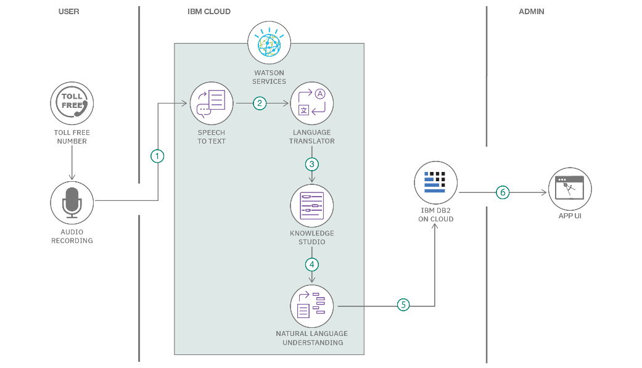

**Table-1 : Components & Technologies:**

|  |  |  |  |
| --- | --- | --- | --- |
| **S.No** | **Component** | **Description** | **Technology** |
|  | User Interface | Web-based dashboard to display traffic analysis results | HTML, CSS, JavaScript, React JS |
|  | Application Logic-1 | Backend to manage request flow and serve predictions | Python, Flask |
|  | Application Logic-2 | Backend to manage request flow and serve predictions | OpenCV, Python |
|  | Application Logic-3 | ML model inference for vehicle detection | TensorFlow / PyTorch |
|  | Database | Stores user data and historical traffic data | MongoDB / MySQL |
|  | Cloud Database | Cloud-hosted storage of real-time and aggregated data | Cloud-hosted storage of real-time and aggregated data |
|  | File Storage | Stores uploaded video feeds and processed images | AWS S3 / Google Cloud Storage |
|  | External API-1 | Real-time weather data to correlate with traffic volume | OpenWeatherMap API |
|  | External API-2 | Google Maps API integration for location-based traffic insights | Google Maps API |
|  | Machine Learning Model | Detects and counts vehicles from video streams | CNN-based YOLOv5 or Faster R-CNN models |
|  | Infrastructure (Server / Cloud) | ML model and app hosted on cloud for scalability | AWS EC2 / GCP Compute Engine / Kubernetes |

**Table-2: Application Characteristics:**

| **S.No** | **Characteristics** | **Description** | **Technology** |
| --- | --- | --- | --- |
|  | Open-Source Frameworks | Used for development and model training | Flask, OpenCV, TensorFlow, React |
|  | Security Implementations | Authentication, API keys, encrypted data, access control | HTTPS, JWT, OAuth2, IAM, Firewalls |
|  | Scalable Architecture | Microservices-based deployment and Dockerized services | Docker, Kubernetes |
|  | Availability | High availability using load balancing and cloud redundancy | AWS Load Balancer, Multi-zone Deployment |
|  | Performance | Real-time inference, optimized APIs, use of cache and efficient DB queries | Redis, Nginx, Indexed Queries |

**References:**

[**https://c4model.com/**](https://c4model.com/)

[**https://developer.ibm.com/patterns/online-order-processing-system-during-pandemic/**](https://developer.ibm.com/patterns/online-order-processing-system-during-pandemic/)

[**https://www.ibm.com/cloud/architecture**](https://www.ibm.com/cloud/architecture)

[**https://aws.amazon.com/architecture**](https://aws.amazon.com/architecture)

[**https://medium.com/the-internal-startup/how-to-draw-useful-technical-architecture-diagrams-2d20c9fda90d**](https://medium.com/the-internal-startup/how-to-draw-useful-technical-architecture-diagrams-2d20c9fda90d)